<https://www.gns3network.com/what-is-dora-process-in-dhcp/DHCP>

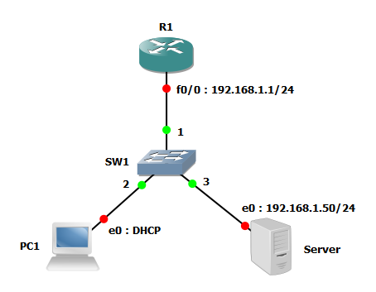

R1#configure terminal

R1(config)#service dhcp

R1(config)#ip dhcp excluded-address 192.168.1.1 192.168.1.100

R1(config)#ip dhcp pool LANPOOL

R1(dhcp-config)#network 192.168.1.0 255.255.255.0

R1(dhcp-config)#lease 2

R1(dhcp-config)#default-router 192.168.1.1

PC1> dhcp

DORA IP 192.168.1.100/24 GW 192.168.1.1

PC1> show ip

NAME : PC1[1]

IP/MASK : 192.168.1.100/24

GATEWAY : 192.168.1.1

DNS :

DHCP SERVER : 192.168.1.1

DHCP LEASE : 172796, 172800/86400/151200

MAC : 00:50:79:66:68:00

LPORT : 10002

RHOST:PORT : 192.168.56.1:10003

MTU: : 1500

PC1>

Server> ip 192.168.1.50/24 192.168.1.1

Checking for duplicate address...

PC1 : 192.168.1.50 255.255.255.0 gateway 192.168.1.1

Server> show ip

NAME : Server[1]

IP/MASK : 192.168.1.50/24

GATEWAY : 192.168.1.1

DNS :

MAC : 00:50:79:66:68:01

LPORT : 10005

RHOST:PORT : 192.168.56.1:10004

MTU: : 1500

R1#show dhcp lease

R1#show ip dhcp bi

R1#show ip dhcp binding

Bindings from all pools not associated with VRF:

IP address Client-ID/ Lease expiration Type

Hardware address/

User name

192.168.1.100 0100.5079.6668.00 Apr 16 2018 12:32 PM Automatic

R1#show ip dhcp server statistics

R1#show ip dhcp pool